**Group 2:**

**Daniel Whitlock**

**Abel Pinales**

**Saw Dennis Kham Myint Htar Oo**

**Murtadha Marzouq**

**Joshua Pucket**

**The ERD in Boyce-Codd Normal Form (BCNF) normalized form is (Description in the Appendix):**

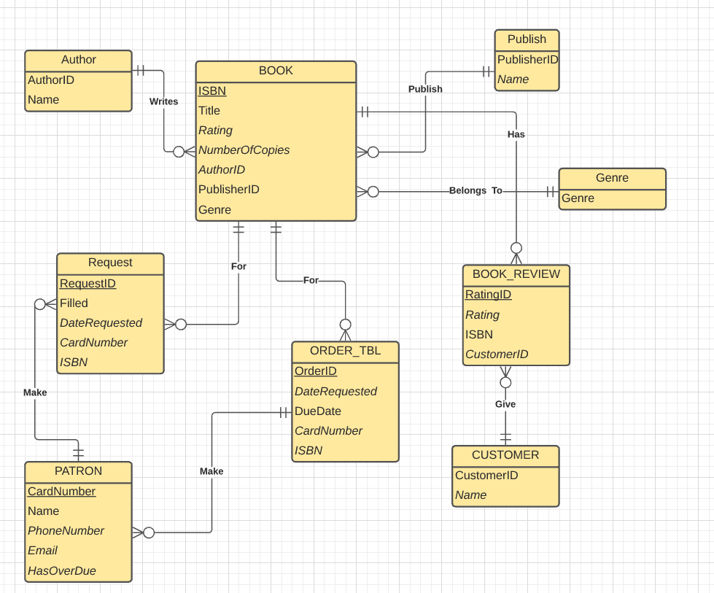

**SCHEMA FORMAT V2 (NORMALIZED I USED TABLE NAMES instead of generic RELATIONS) EX**:

**R**(**A**,**B**,**C,D**) { **A** -> **BCD** , **BC** -> **AD** , **D** -> **B** } --FUNCTIONAL DEPENDENCY



**CREATE TABLES STATEMENTS**:

<http://34.150.201.142/team02/PROJECT/SQL/CREATE%20TABLES.TXT>

**INSERT DATA (2 working ways, SQL is easier than CSV)**:

1. We have SQL/TEXT file prepared:

<http://34.150.201.142/team02/PROJECT/SQL/>

<http://34.150.201.142/team02/PROJECT/SQL/INSERT%20STATEMENTS.txt>

1. We have CSV file prepared:

<http://34.150.201.142/team02/PROJECT/CSV/>

**IMPORT DATA (CSV) STATEMENTS**:



**IMPLEMENTED INSIDE THE DATABASE (team02):**

**APPENDIX:**

Sharing the process:

TO RETHINK THE Schema to BCNF Normalized:



**SCHEMA FORMAT V3**:**:**

**NOTE**: WE CREATED SEVERAL SCHEMA FORMATS TO COVER OUR BASIS

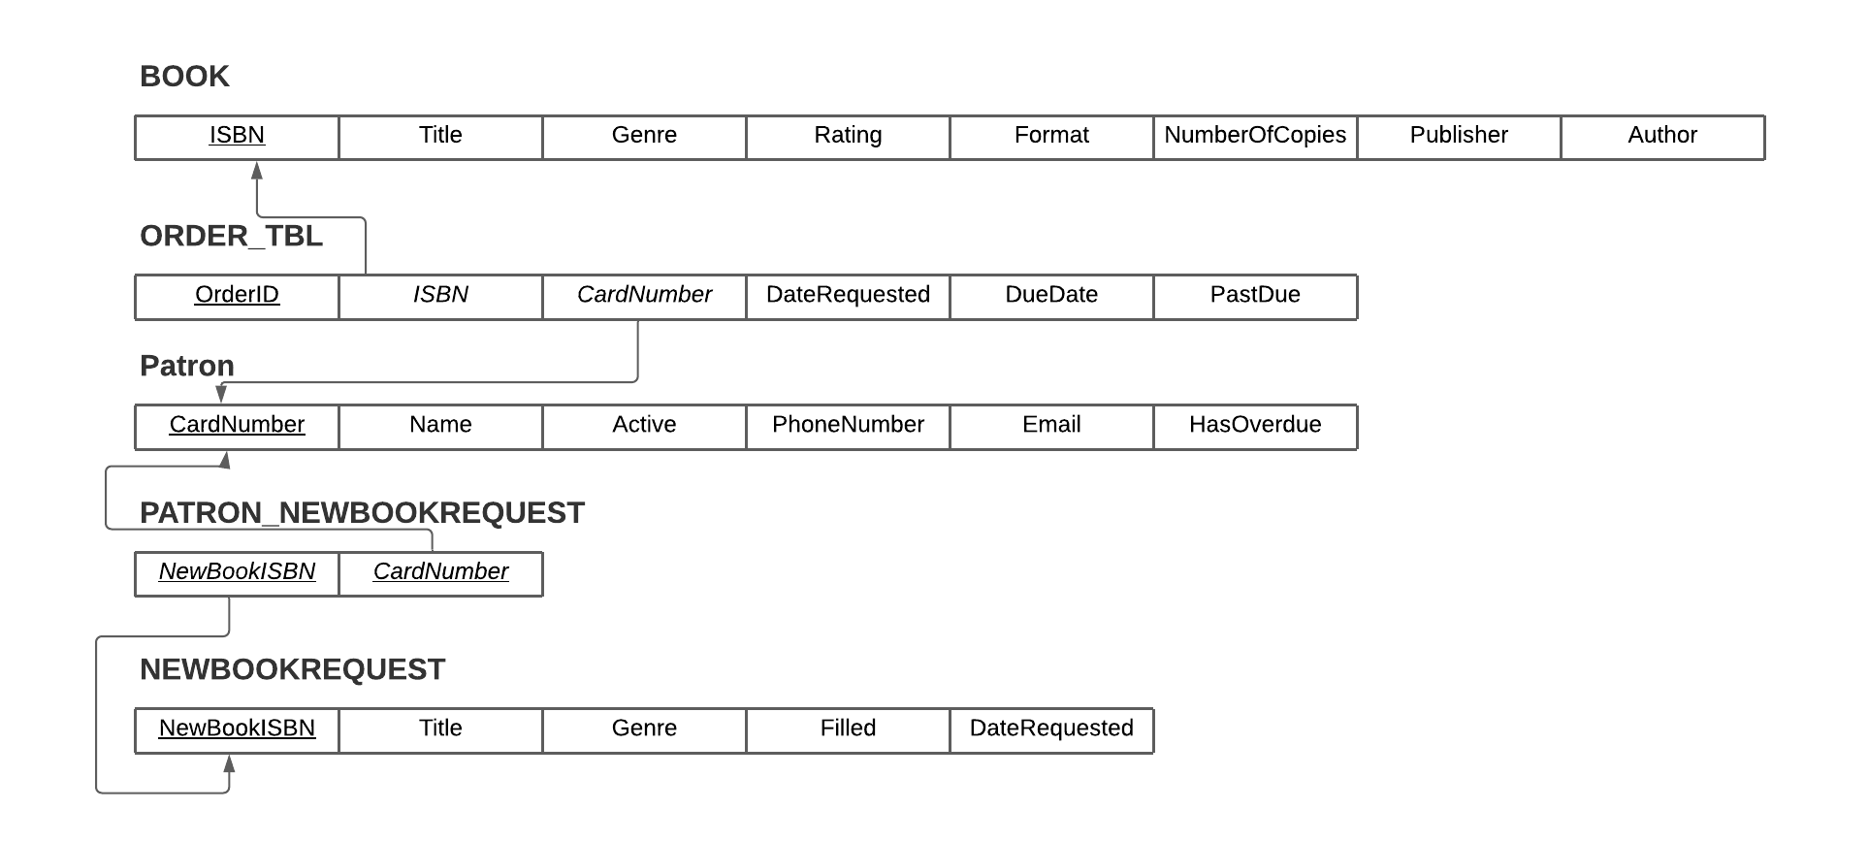

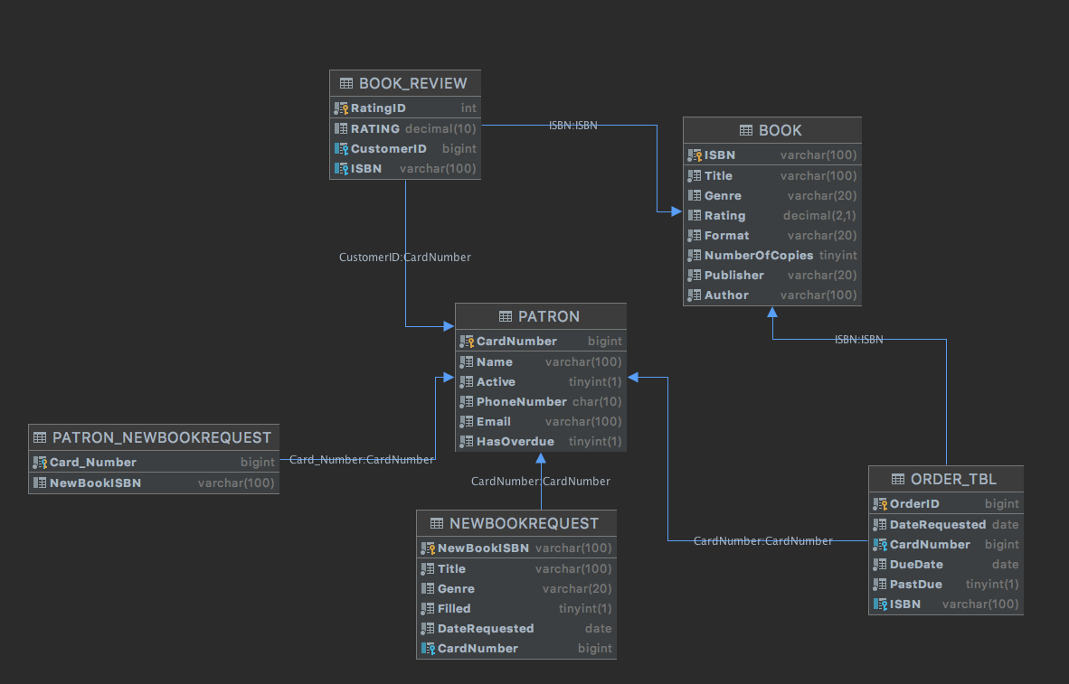

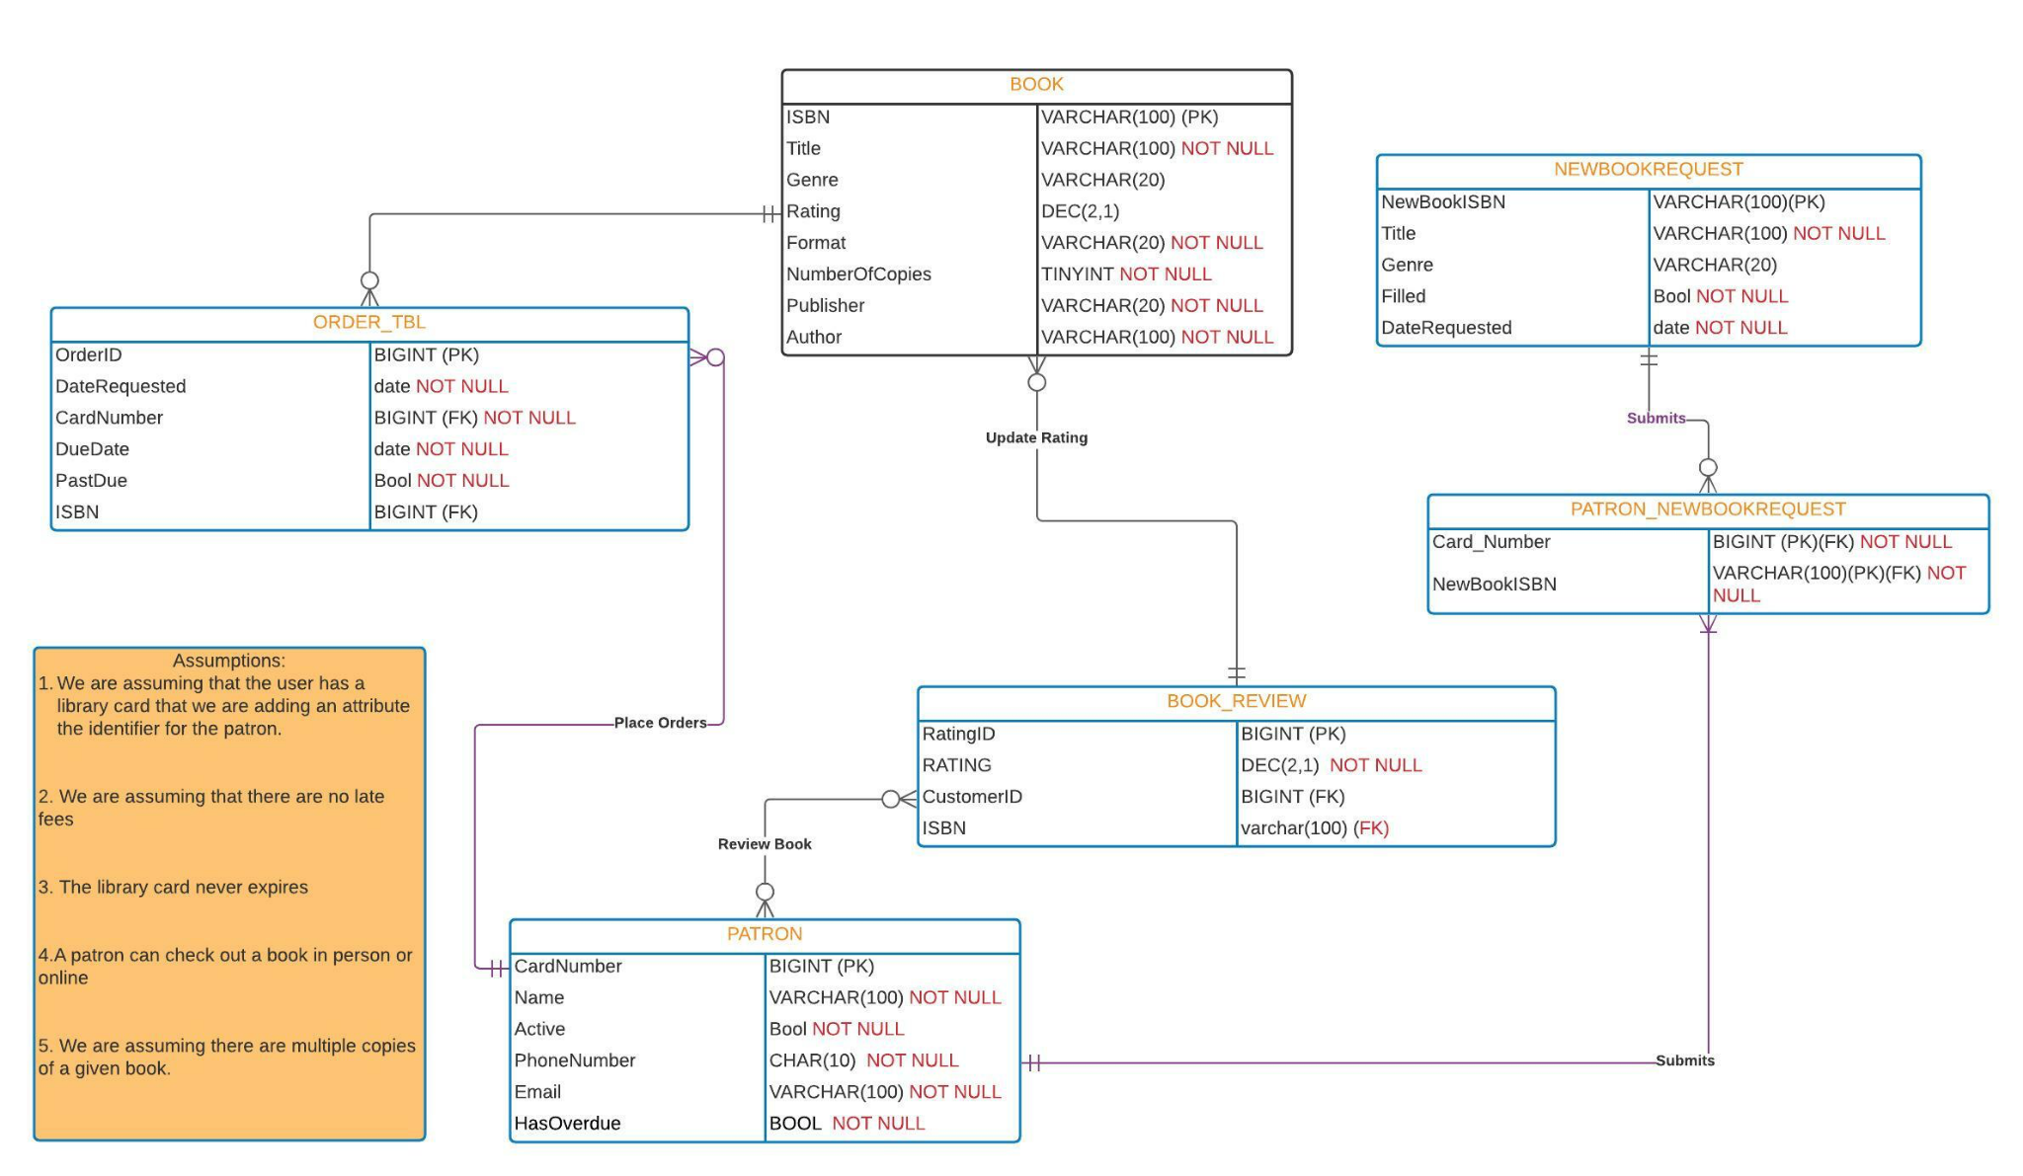

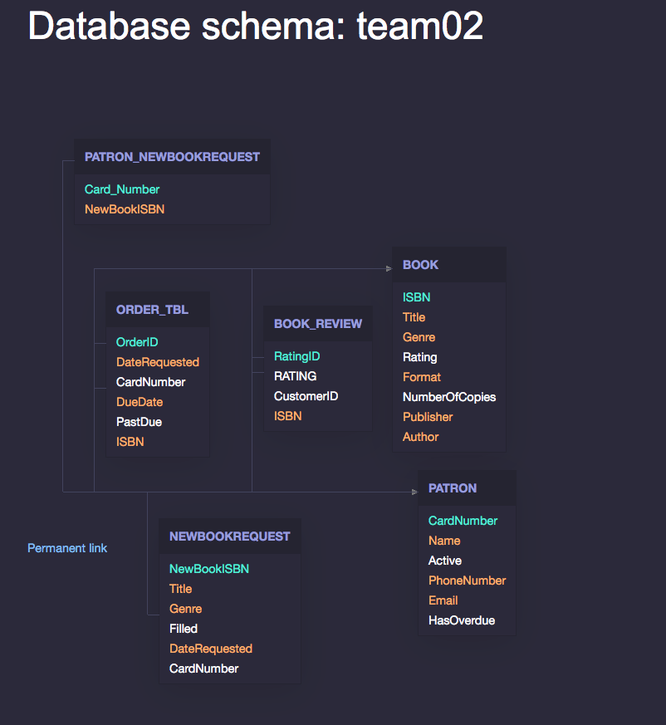

**NOTE**: ALL DATA IS NOW OPERATIONAL ON THE **team02** DB.

**Grading**: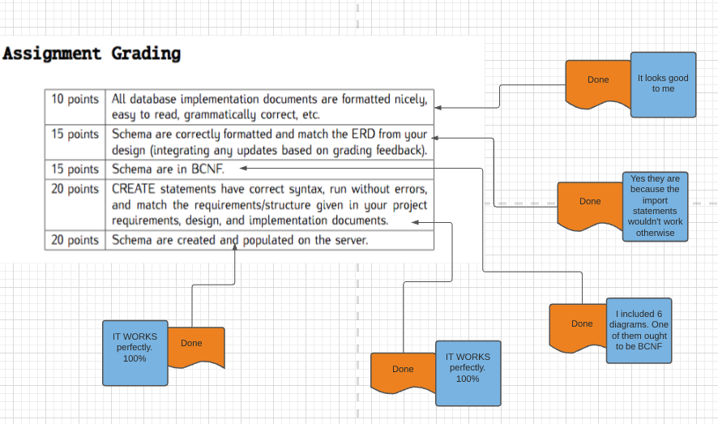

Bonus: (free DNS) the Apache server doesn’t have a SSL Certificate, so HTTPS doesn’t matter anyways. You will get an error either way:

<http://itis3160.ddns.net/team02/PROJECT/>